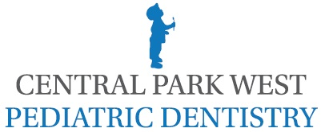

Dear Parent,

Welcome to our wonderful family of patients! Thank you for selecting us as your personal dental care team for your child. We will strive to make your relationship with us a pleasant and rewarding one.
A firm foundation is needed upon which we can base recommendations for your child’s dental health. Therefore, we will complete a thorough dental examination during the initial appointment. We will evaluate your child’s dental growth and development as well.
Preventative dentistry is the most important service we have to offer. We will show you how to care for your child’s teeth and gums so that they can maintain a beautiful smile. Preventative examinations on a regularly scheduled basis will give your child the maximum opportunity for a long-term dental health.
Good communication is essential to forming a satisfactory relationship. If you ever have a concern about treatment, fee, or service, please feel free to discuss it immediately and openly with any of us. We welcome your comments and suggestions, and want to do everything we can to make your visit a pleasant experience.
Creating and maintaining your child’s oral health is our primary goal. Thank you for giving us the opportunity to pursue this goal with you.

Sincerely,
Dr. Robert Peracchia, DDS
Dr. Alexis Cohen, DDS
Dr. Christina Youngerman, DDS

